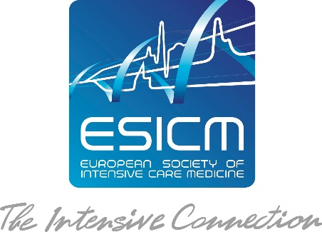

Application Form
for Getting your Project
Endorsed by ESICM

This form should be used to present your Project to the ESICM Research Committee for review. Please complete it in English and send it by e-mail to research@esicm.org. The Research Committee will evaluate the Projects on a monthly basis. Please provide the protocol when submitting.

Title of the Project (Full title and Acronym)

Project Steering Committee and / or Advisory Board
Chair / Lead Investigator (please indicate name, hospital /university, city and country)
* Please note that the lead investigator must be an ESICM member

Contact Person (if different) –please indicate address, email & phone

Members of the Steering Committee

Please indicate if the Project is submitted by an ESICM section or another group.

ESICM section: is there an ESICM Section involved?

Declaration of Potential Competing Interests

Your Link and/or Your team’s link to ESICM? Have you been or are you actively contributing to ESICM? Do you have evidence of past and current collaboration with ESICM?

Can you elaborate on why you are seeking the endorsement of your project by ESICM?

Objective (primary and secondary)

Design and Population

Development of the Project (please describe elements of item generation, iterative item reduction, results of pilot testing, measure of internal consistency and reliability)

Methods and Analysis

Administration of the Project

Response rate and sample size

Expected results

How do you anticipate this Project may inform future research and/or clinical practice?

Organisation of the Project
Number of Participants:

We wish to involve medical professionals from __ICUs and ___patients.

Geographical scope of the project

ٱ National.
ٱ EU Member States
ٱ All European countries
ٱ International
Planning

Starting date: Immediately after endorsement by ESICM

Duration: ……. months (it can be extended on request)

Ethical Issues

X. Plan for dissemination of results
Please explain any particular plan you may have for publication and presentation of your project’s results.

Finances

Please present your project’s budget, in EURO (as detailed as possible):

Please mention if you are preparing or have already submitted funding applications, if you have obtained or are seeking a grant, as well as the source(s) of funding envisaged or obtained.Please also mention if you have specific ideas of potential sources of funding for your project (e.g. contact with industry), and whether you need help to apply to these sources.

I, the lead investigator, hereby declare that all the information provided in this application is true.

ESICM Collaboration Offer
Circulation to ESICM Members:
Your Project will be circulated to the ESICM membership database. All relevant documents should be sent in an electronic format to the ESICM office.
For sake of confidentiality, the Office will not communicate any e-mail address list of its members (see ESICM policy). The e-mailing will be carried out by ESICM.
Please note that your Project information package will only reach ESICM members who have communicated their e-mail address.

Opportunity to advertise your Project through ESICM Communication Media:
Your Project will be advertised on the Project section of the ESICM research webpage.
You may be invited to produce a poster presenting your Project or the related results, which benefits from great exposure during ESICM Annual Congress.

Opportunity to display the ESICM Logo:
You will be entitled to display the ESICM logo together with the following sentence: “Endorsed by the European Society of Intensive Care Medicine” on your documentation, promotional material, emails and websites. ESICM should be kept informed of any promotional material embedding the ESICM logo.
Please contact the ESICM office research@esicm.org for a soft copy of the ESICM logo in an approved format.

Your Liabilities
You must mention that your Project is endorsed by the European Society of Intensive Care Medicine in your publications.
You may be invited to provide an update on your Project during Research Committee meetings.
You may be also requested to provide a brief report on your Project developments to be posted on the ESICM website.

By submitting an application, we assume that you agree on the ESICM endorsement conditions and that you acknowledge, understand and accept the above liabilities.

Acceptance of your Application and Next Steps
Should your Project be selected, you will be informed by e-mail of the decision of the Research Committee members. The e-mail will be signed by the Chair of the Research Committee on behalf of the Research Committee members, who have reviewed and approved your application.

local funding (region, university, hospital, trust fund); national funding (Research Council, private foundation, etc); international funding (European Union, NIH, etc); industry funding; other sources

