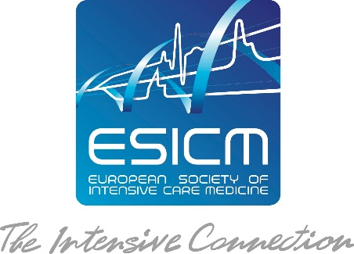

Application Form
for Getting your Survey
Endorsed by ESICM

This form should be used to present your survey to the ESICM Research Committee for review. Please complete it in English and send it by e-mail to research@esicm.org. The Research Committee will evaluate the surveys on a monthly basis. Please provide the questionnaire when submitting.

Title of the Survey (Full title and Acronym)

Survey Steering Committee and / or Advisory Board
Chair / Lead Investigator (please indicate name, hospital /university, city and country)
* Please note that the lead investigator must be an ESICM member

Contact Person (if different) –please indicate address, email & phone

Members of the Steering Committee

Please indicate if the survey is submitted by an ESICM section or another group.

ESICM section: is there an ESICM Section involved?

Declaration of Potential Competing Interests

Your Link and/or Your team’s link to ESICM? Have you been or are you actively contributing to ESICM? Do you have evidence of past and current collaboration with ESICM?

Objective (primary and secondary)

Design and Population

Development of the Survey (please describe elements of item generation, iterative item reduction, results of pilot testing, measure of internal consistency and reliability)

Methods and Analysis

Administration of the survey

Response rate and sample size

Expected results

How do you anticipate this survey may inform future research and/or clinical practice?

Organisation of the Project
Number of Participants:

We wish to involve medical professionals from __ICUs and ___patients.

Geographical scope of the project

ٱ National.
ٱ EU Member States
ٱ All European countries
ٱ International
Planning

Starting date: Immediately after endorsement by ESICM

Duration: 3 months (it can be extended on request)

Ethical Issues

I, the lead investigator, hereby declare that all the information provided in this application is true.

ESICM Collaboration Offer
Circulation to ESICM Members:
Your survey will be circulated to the ESICM membership database. All relevant documents should be sent in an electronic format to the ESICM office.
For sake of confidentiality, the Office will not communicate any e-mail address list of its members (see ESICM policy). The e-mailing will be carried out by ESICM.
Please note that your survey information package will only reach ESICM members who have communicated their e-mail address.

Opportunity to advertise your survey through ESICM Communication Media:
Your survey will be advertised on the survey section of the ESICM research webpage.
You may be invited to produce a poster presenting your survey or the related results, which benefits from great exposure during ESICM Annual Congress.

Opportunity to display the ESICM Logo:
You will be entitled to display the ESICM logo together with the following sentence: “Endorsed by the European Society of Intensive Care Medicine” on your documentation, promotional material, emails and websites. ESICM should be kept informed of any promotional material embedding the ESICM logo.
Please contact the ESICM office research@esicm.org for a soft copy of the ESICM logo in an approved format.

Your Liabilities
You must mention that your survey is endorsed by the European Society of Intensive Care Medicine in your publications.
You may be invited to provide an update on your survey during Research Committee meetings.
You may be also requested to provide a brief report on your survey developments to be posted on the ESICM website.

By submitting an application, we assume that you agree on the ESICM endorsement conditions and that you acknowledge, understand and accept the above liabilities.

Acceptance of your Application and Next Steps
Should your survey be selected, you will be informed by e-mail of the decision of the Research Committee members. The e-mail will be signed by the Chair of the Research Committee on behalf of the Research Committee members, who have reviewed and approved your application.

