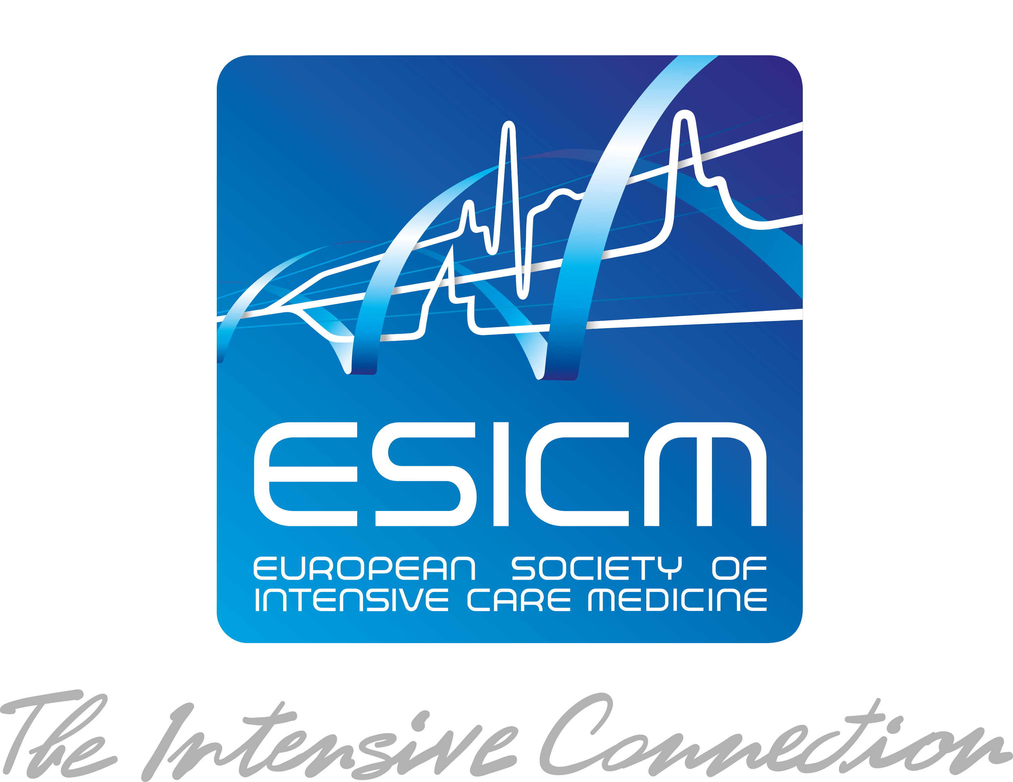

Copyright Transfer Agreement Clinical Case Contest

In consideration of the fact that the European Society of Intensive Care Medicine (ESICM), its affiliates and agents, undertake to publish my Clinical Case as a chapter/article (hereinafter referred to as the “Work”):

- I affirm that the Work is original and previously unpublished and that neither the Work or any material portion thereof is in the public domain; that it contains no matter that is libellous or is otherwise unlawful or that invades individual privacy or infringes any proprietary right or any statutory copyright or privacy law; and I agree to indemnify, defend, and hold the publisher harmless against any claim, damages, lawsuits, causes of action, liabilities, costs, obligations, expenses, or judgment arising out of any claim or allegation by a third party that the Work or the publication of the Work infringes upon or violates any rights of such third party.

- I warrant that the Work has not been published elsewhere in whole or in part; that I have not given anyone else permission to publish or otherwise exploit any part of the Work, including in any other manuscript; and that the Work is not currently under consideration or accepted for publication elsewhere in its, or any other, format. Should the Work contain any material that requires written permission to be included in the Work, I will obtain such permission at my own expense from the copyright proprietor.

- I (and my co-authors) hereby assign and transfer to the ESICM all rights of copyright ownership and permissions to the Work, including without limitation or restriction, all rights of reproduction, derivation, distribution, sale, reuse, translation and display of the Work, in whole or in part, including recompilation, cross-publication, and stand-alone publication, in any and all forms of media now or hereafter known, including all electronic and digital media, as protected by the laws of the European Union and foreign countries and to authorize others to make such uses of the Work. These rights will become the property of the ESICM from the date of acceptance of the Work for publication and extend for the life of the copyright. I understand that the ESICM, as copyright owner, has authority to grant permission to reproduce the Work. If my Work is not accepted for publication by the ESICM, my signed Copyright Transfer and Disclosure Form will immediately become null and void and have no force, binding power, or validity.

Name:

Signature:

City/Country of Residence:

Date ________________

