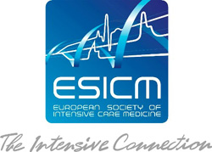
The ESICM Research awards programme 2021
Participation rules and regulations

Before filling in this application form, you should first have carefully read the instructions about the call for proposals and related information as available from the ESICM Research Awards webpage https://www.esicm.org/research/awards-2/. Please, read the ESICM 2021 Awards Programme Overview and procedure before applying.
Please prepare your application offline as much as possible following the instructions provided on that page. If it is not helpful, please email research@esicm.org and request a template of what will be asked. Thank you.
General conditions applicable to ESICM Research and Industry Awards
 | a. | Only online application forms will be accepted. All documents must be submitted in English.
 | b. | The selection process is organised in three steps:  Pre-selection step: the Jury (Research Committee and potentially external experts) will select projects based on feasibility (budget, timeline), methodology, research design and statistical plan presented on a short outline proposal.  Review step: the pre-selected projects will be reviewed by external experts, each proposal is reviewed by 2 to 4 reviewers.  Jury selection step: the Jury will select awardees according to the reviewers’ marking, comments and discussion among the Jury members.
 | c. | The application deadline for the first step will be on May 1st at 23:59 (CET). After pre-selection reviewing process, selected candidates will be invited to fill in the full application and will have around 3 weeks to complete it.
 | d. | Applications can be submitted to maximum 3 award proposals, including those of the Industry Research Award programme. Candidates must specify in the online application form their preference for awards in case their application is ranked first by more than one jury member.
 | e. | Applications that have undergone a review in 2018, 19 and 20 can be resubmitted provided that they have been substantially modified.
 | f. | Applications should normally specify only one institution (in Europe) as hosting unit.
 | g. | The Awards are not intended to run concurrently with other awards greater than 15,000 euros, even those funded by other agencies. Funds used to secure ethics approval, insurance or permission to perform animal research will not be taken into account in the 15,000 euros limit. The Awards are not granted for basic training, courses, lectures, meetings, conferences, congresses, etc. or for visiting institutions.  Applicants must have paid their 2021 ESICM membership fee. If you are applying to become an ESICM member, please note that membership processing can take up to 1 week. If you are applying for membership and have not received your membership ID, please contact members@esicm.org or research@esicm.org to find out how you can continue your application while your membership application is being processed.
 | h. | Applications can come from anyone who is a member of the society.
 | i. | No names or institutions should be named in all fields describing the study, except it is not otherwise possible to describe it
 | j. | Applicants who have already received an ESICM Award in the past may apply for a further ESICM Award.  The Young Investigator Award, the ESICM Levi-Montalcini Biomedical Science Award and the Next Start-Up Grant can be only received once each by an ESICM member.
 | k. | The Awardee is banned from any further ESICM funding (awards, fellowships) if any of the following occurs:  - If the work is not conducted within 3 years (Next Start-Up grant within 6 years) and the Awardee did not provide annual reports (https://www.esicm.org/wp-content/uploads/2019/10/Awardee_ReportForm.xlsx) and explanation for the delay  - If there is no mention of the ESICM Award funding the application

Title of Research Project / Analysis

Name of the project (full name and acronym)

Project title * : ______________________________________________________

Geographical scope of the project : In which country will the project be done? *
______________________________________________________

List of countries contributing to the design and/or conduct of the project *
______________________________________________________

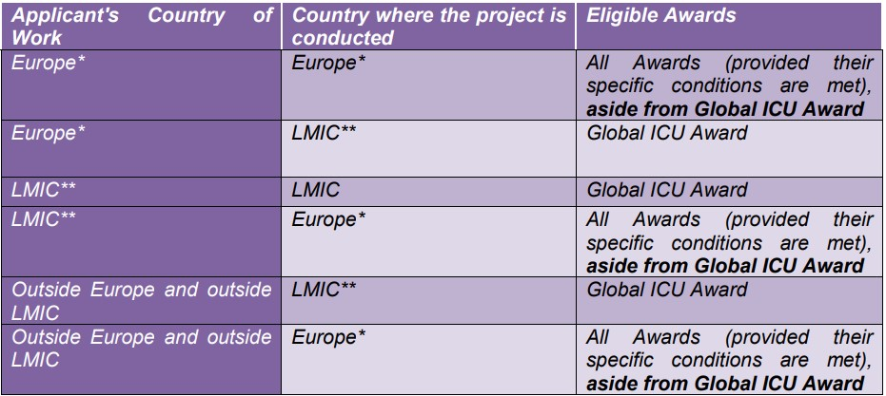

Previous Awards

Have you been awarded an ESICM Grant or Prize in previous years?*
⃝ Yes

⃝ No

Have you won an ESICM Award in previous years?
⃝ Yes

⃝ No

If yes, please fill the following table with the informations about the ESICM Awards won in the past :

Award | Year | Project over (yes / no) | Final report sent (yes / no)

If your project if over and you did not send your final report, please send it to research@esicm.org.
The Awardee is banned from any further ESICM funding (awards, fellowships) if any of the following occurs:
- If the work is not conducted within 3 years (Next Start-Up grant within 6 years) and the Awardee did not provide annual reports (https://www.esicm.org/wp-content/uploads/2019/10/Awardee_ReportForm.xlsx) and explanation for the delay
- If there is no mention of the ESICM Award funding the application

Awards

Awards choice

Please select up to 3 awards you wish to apply for.

- The ESICM Basic Science Awards
- The ESICM Clinical Research Awards
- The ESICM Established Investigator Award
- The ESICM Young Investigator Award
- The Family Partnership Award
- The Global ICU Award
- The NEXT Start-up Grant
- Fisher&Paykel Healthcare SAS

1st choice * ______________________________________________________
2nd choice ______________________________________________________
3rd choice ______________________________________________________

For award description, please refer to the ESICM Award presentation and Industry Research Award documents available on the www.esicm.org website.

Area Of Research / Analysis

Please check the boxes of the area of your project / analysis : *
(please choose at least one)

⃝ Clinical
⃝ Patient Safety
⃝ Experimental

Other, specify : ______________________________________________________

• Multinational component *
Please describe the multinational component of your study. This field is limited to 500 characters :
______________________________________________________

Supervisor

Supervisor contact information
If you don’t have a supervisor / same information as applicant’s details :

Title * ______________________________________________________
Surname * ______________________________________________________
Firstname * ______________________________________________________
Name of institution or Hospital *______________________________________________________
City * ______________________________________________________
Country * ______________________________________________________
Phone number * ______________________________________________________
Email address * ______________________________________________________

Research / Analysis summary

Please advise an upload of an image here is not allowed. This field is limited to 450 characters

______________________________________________________

Research plan - Objectives

Study type / design *

Please fill in the research plan summary. This field is limited to 100 characters

______________________________________________________

Objectives *
This field is limited to 300 characters

______________________________________________________

Research plan - Medical problem / Background

Medical problem / Background

Delineate the intervention that should be investigated; clearly describe the different groups and the intervention(s) in detail and justify why the stated groups are necessary. If not interventional
• Introduction *
This field is limited to 150 characters

______________________________________________________

• Research question(s) *
This field is limited to 300 characters

______________________________________________________

• The Need For research *
This field is limited to 150 characters

______________________________________________________

Research plan - Methods and Measurements (1/3)

Methods and Measurements

• Inclusion / Exclusion Criteria *
Inclusion / Exclusion criteria : Describe methods used. Standard methods need only be named, but uncommon or new methods may need a more detailed description. This field is limited to 500 characters

______________________________________________________

• Outcome measures *
Outcome measures : Present as clearly and derailed as possible the outcome of the study in summarised form. Only a short discussion. Focus on what can be concluded from the data and explain them in simple words. Avoid any speculations. This field is limited to 1000 characters

______________________________________________________

Methods and Measurements - Statistical Analysis

Indicate how the data will be analysed and which statistical tests will be used.
This field is limited to 1000 characters

______________________________________________________

Research Plan – Sample size And insurance

• Justification for sample size *
Do NOT add any information in this field which is not related to the sample size/power calculation
This field is limited to 1000 characters

______________________________________________________

• Insurance *

⃝ No insurance necessary for that type of study (e.g. animal research)
⃝ No insurance needed according to local regulations
⃝ Insurance is provided by institution or other entity without costs
⃝ Insurance must be paid from the budget

Ethics

Please check one of the following choices : *

⃝ This project has been approved by the institutional committee reviewing human or animal investigations.

⃝ This project has been submitted to the institutional committee reviewing human or animal investigations, but is not yet approved

⃝ This project will be submitted to the institutional committee reviewing human or animal investigations

Name of the Ethics Committee : ______________________________________________________

If your project has been approved, please attach a copy of the approval.

Budget Details

Personnel (e.g statistician cost) * : ______________________________________________________
(e.g statistician cost. Only include the applicants salary if it must be paid from the budget)

Equipment, supplies and travel * : ______________________________________________________

Consumable / Reagents * : ______________________________________________________

Insurance * : ______________________________________________________
(only if must be paid from the budget)

Other costs (no indirect costs) * : ______________________________________________________

Total cost of the project * : ______________________________________________________

Already acquiered funds * : ______________________________________________________
(fill in details below in Current support for the proposed project)

Total funds requested from ESICM * : ______________________________________________________
(cannot exceed the maximum amount for this Grant Category)

Applied funds elsewhere* : ______________________________________________________
(fill in details below in Current support for the proposed project)

With the following questions, there should be a clear picture of all necessary resources and support available or needed.
If you apply for awards with different support you have to provide information how you proceed if only the smaller award will be granted.

Budget justification *
Please explain in detail the budget costs This field is limited to 5000 characters
______________________________________________________

List of facilities, equipment, supplies and services already in place (and therefore do not have to be calculated into the budget of the study) *
This field is limited to 2000 characters
______________________________________________________

Conflict of interest

⃝ I declare that I have no conflict of interest with any of the ESICM Research Committee members reviewing the present application : Yes / No

⃝ I have a conflict of interest with the following ESICM Research Committee member(s) reviewing this application :

⃝ Andrew Conway Morris
⃝ Ben Creagh-Brown
⃝ Jan DE WAELE
⃝ Nikos Efstathiou
⃝ Sharon Einav
⃝ Paul ELBERS
⃝ Gunnar Elke
⃝ Laura Galarza
⃝ Sophie HAMADA
⃝ George Karlis
⃝ Marc Leone
⃝ Mariangela Pellegrini
⃝ Lise Piquilloud
⃝ Chiara ROBBA
⃝ Bernd Saugel
⃝ Antoine SCHNEIDER
⃝ Arzu TOPELI ISKIT
⃝ Diederik VAN DIJK

Declaration of Intent

I confirm I have read the awards guidance document and comply with the rules * :
⃝ Yes

⃝ No

I confirm that the study has not been performed yet * :
⃝ Yes

⃝ No

I grant permission that my data is used by ESICM and its officers. I agree that third parties will be granted access to my data for reviewing and educational purposes * :
⃝ Yes

⃝ No

(details of the privacy policy can be found at https://www.esicm.org/privacy-policy-2/)

Application validation

Any subsequent modification will NOT BE POSSIBLE after submitting your application.

