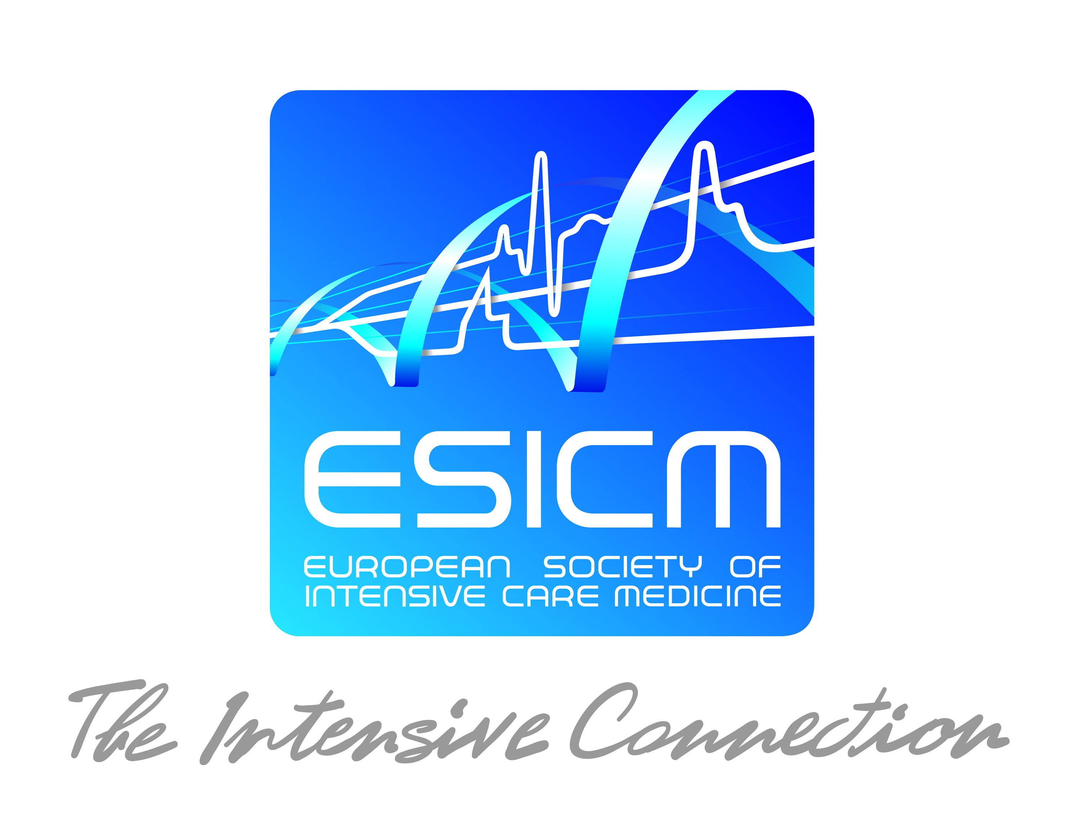

The ESICM and Industry Research Awards 2019

ESICM actively supports launching efforts to fund European research initiatives led by young investigators. The primary goals of this programme are:

- To develop an attractive programme of fellowships to support research and training in intensive care medicine in Europe;

- To contribute to the implementation of new techniques in Europe, through the support and training of fellows in research;

- To raise the image of the ESICM in the international community;

Through its Research Committee, ESICM is committed to enforce strict rules for the management of the fellowships and aims to ensure the high quality of the work supported. To promote the development of European research programmes, the Research Committee and Jury members will be asked to give priority to applications conducted under the supervision of ESICM members.

1. ESICM Awards programmes for 2019

- The ESICM/ Awards are funded by ESICM with the objective of enabling young investigators and clinicians, who are in the early stages of their careers to carry out basic or clinical research projects and further, to develop, acquire, and apply advanced research procedures and techniques in the area of intensive care medicine within a 12-month work period in a European country* or in a Low & Middle Income Country (LMIC)** for Global ICU Award. The following grants are available for 2019:

- The ESICM Young Investigator Award will support the development of research activities undertaken with the active contribution of the applicant. The specific intent is to provide support for young and talented physicians/scientists that have the potential to become outstanding independent investigators in the field of intensive care and emergency medicine. Research proposals may rely on approaches ranging from basic cellular responses to outcome research, and may include clinical applications as well as translational science. The age limit is 40 at the time of the application.

- The ESICM Established Investigator Award will support the research activities of a senior physician/scientist active in clinical or basic research. The specific intent is to provide support for investigators who have already established their independent research program in the field of intensive care and emergency medicine, and who can demonstrate a commitment to facilitate research training of young colleagues. The research proposal may rely on approaches on topics ranging from basic cellular responses to outcome research, and may include clinical applications as well as translational science.

- The ESICM Clinical Research Award will support a research project to be performed by an investigator in a clinical environment. Some aspects of the proposal may involve collaboration with research laboratories. However, applications that lack a clinical component will not be considered. Approaches may vary topically from physiology, diagnostic procedures, therapeutic interventions, to epidemiologic studies and evaluation of practices.

- The ESICM Basic Science Award will support a research project to be performed by an investigator in a research laboratory. Topics may range from basic cellular and molecular physiology, cell biology, molecular biology and genetics to animal physiology and translational science.

- In order to foster progression of women in academic careers, the ESICM Levi-Montalcini Biomedical Science Award will support the development of research activities undertaken with the active contribution of a female applicant. The specific intent is to provide support for young and talented female physicians-scientists that have the potential to become outstanding independent investigators in the field of intensive care medicine and emergency medicine. The research proposal may rely on approaches ranging from basic cellular responses to outcome research, and may include clinical applications as well as translational science.

- The Global ICU Award aims at project conducted in a Low & Middle Income Country. The projects should have an educational element focusing on improving patient care.

- The Family Partnership Award aims at research projects conducted in Europe focusing on families’ needs and expectations, carers & patient interaction, long-term outcomes in ICU

- The deliverables include the submission of a research abstract to the Annual Congress of ESICM. Submission for publication of the final results to Intensive Care Medicine is strongly encouraged. In addition, each Award requires an administrative end-of-project report in English within three months of the end of the project.

- Applications for projects relevant to developing central and eastern European countries are particularly encouraged.

Applicant's Country of Work | Country where the project is conducted | Eligible Awards
Europe* | Europe* | All Awards (provided their specific conditions are met), aside from Global ICU Award
Europe* | LMIC** | Global ICU Award and GE-ESICM Point Of Care challenge award
Europe* | Outside Europe and outside LMIC | Only GE-ESICM Point Of Care challenge award
LMIC** | LMIC | Global ICU Award and GE-ESICM Point Of Care challenge award
LMIC** | Europe* | All Awards (provided their specific conditions are met), aside from Global ICU Award
LMIC** | Outside Europe and outside LMIC | Only GE-ESICM Point Of Care challenge award
Outside Europe and outside LMIC | LMIC** | Global ICU Award and GE-ESICM Point Of Care challenge Award
Outside Europe and outside LMIC | Europe* | All Awards (provided their specific conditions are met), aside from Global ICU Award
Outside Europe and outside LMIC | Outside Europe and outside LMIC | Only GE-ESICM Point Of Care challenge award

2. General Conditions

- Only 2019 ESICM members are allowed to submit an application. If you are not yet a member, please proceed before submitting your project. If you were a member in the previous year, please make sure to renew your membership for the applying year.

- For 2019, the European Society of Intensive Care Medicine (ESICM) offers several research awards for professionals actively engaged in clinical and basic research in intensive care medicine:

Programme | Duration | Amount
The Young Investigator Award | 12 months | €20,000
The Clinical Research Award | 12 months | €20,000
The Basic Science Award | 12 months | €20,000
The Established Investigator Award | 12 months | €20,000
The Levi-Montalcini Biomedical Science Award | 12 months | €20,000
The Next Start-up Grant: €25,000 per year for 2 years | 24 months | €50,000
The Global ICU Award | 12 months | €15,000
The Family Partnership Award | 12 months | €15,000

- Along with the ESICM Research Awards, we have two industry awards in 2019: the Baxter- ESICM Research Award (€20,000) and the Epimed Solutions-ESICM Award on Quality Improvement and Patient Safety (€15,000) and GE-ESICM Point Of Care challenge awards. More details on https://www.esicm.org/research/awards-2/

- The ESICM research awards are funded by ESICM, to enable qualified investigators to carry out specific basic and clinical research projects in a European country as defined by the ESICM statutes. Although investigations can be performed in the country of origin of the applicant, ESICM will encourage applications that foster scientific exchanges between European research centres.

- Awards are not intended to run concurrently with other awards greater than €15,000, even those funded by other agencies. Funds used to secure ethics approval, insurance or permission to perform animal research will not be taken into account in the €15,000 limit. Awards are not granted for basic training, courses, lectures, meetings, conferences, congresses, etc. or for visiting institutions.

- ESICM does not cover any tax issue that may arise either in the home or host country and any applicable taxes must come out of the initial Award. ESICM is a non-governmental international organisation whose awards are not automatically endowed with any particular tax privileges. It is the sole responsibility of the recipient of an award to pay any tax which may be levied upon him/her by the appropriate national authority.

- In addition, ESICM awardees are not insured by ESICM against medical expenses for themselves or their families; neither are they insured for accidents during their travel to and from the host institution. ESICM does not recognize recipients of its awards as agents or employees of ESICM and accepts no liability in respect of any of their actions or activities or in respect to the health or safety of their persons. In their own interest, recipients of the fellowships are, therefore, urged to make sure that they, their families and the institutions which receive them are fully covered by necessary insurances.

3. Candidates

- Candidates must possess appropriate professional qualifications and experience according to the specific Award applied for. Physicians, scientists, nurses or health-allied professionals are eligible candidates for the Awards. Applications from nurses and health-allied professionals should be supported by a research supervisor (M.D. or Ph.D).

- Candidates must be actively engaged in intensive care and emergency medicine or in intensive care research, with appropriate scientific or medical qualifications.

- Candidates applying for the Next Start-Up Grant should be board-certified intensive care physicians within 5-years from consultancy who can demonstrate a solid background in research.

- For all other awards, there is no age limit. Applicants should hold a position at their home institutions or should provide a letter from the supervisor that describes career plans after the Award. In cases in which the Award is used to fund a research fellowship/ visiting research fellowship abroad, the return of the Fellow to the home institution at the end of the fellowship/ a visiting research fellowship is encouraged.

- Candidates must be members of ESICM or submit an application to become a member of ESICM prior to submission of their award application.

- The research programme must be conducted in a host institution in Europe (except for the Global ICU Award). When applicable, the proposal should elaborate on how the partnership between the host and the candidate would take full advantage of the unique facilities, resources, and materials available in their (respective) countries. Candidates must have adequate fluency in a language that permits effective communication at the host institution.

- Candidates who have already received an ESICM Award in the past may apply for a further ESICM Award after 12 months.

4. Applications

- The link to the online application platform will be available from the Research Awards web pages on the ESICM website as of February 4st, 2019.

- Applications can be submitted for up to three Awards, including the Industry Research Award programme.

- Applications that have undergone a review and selection process and were not approved for funding cannot be resubmitted in the following year(s) without further modification.

- Applications should normally specify only one institution as a hosting unit.

5. Selection

- Selections will be made on the basis of scientific and expert evaluation of the application and the proposed work as set out by the candidates in the project description. Members of the Research Committee and reviewers of the highest international standing in their respective fields will carry out this task.

- The selection process is organised in three steps:

- Pre-selection step: the Jury (Research Committee and potentially external experts) will select projects based on feasibility (budget, timeline), methodology, research design and statistical plan presented on a short outline proposal. Deadline to submit the short application: March, 25th 2019 at Midnight.
- Pre-selected candidates will be invited to complete the full application from mid-April. Candidates will have 3 weeks to complete the full application form.
- Review step: the pre-selected projects will be reviewed by external experts, each proposal is reviewed by 2 to 4 reviewers.
- Jury selection step: the Jury will select awardees according to the reviewers’ marking, comments and discussion among the Jury members.
- Results will be given during the summer
- The review process will involve appreciation of the significance and the originality of the research project, the proposed approach, the investigators profile and the research environment in which the project will be conducted. A quantitative evaluation grid will be used to help members of the Selection Committees in the decision process.

- To guarantee a fair selection process and to avoid any potential conflicts of interest, applications involving a member (or the institution) of the Research Committee will be discussed in the absence of this member.

- The assessments are strictly confidentialand cannot be divulged outside ESICM, or to the candidates themselves.

- No distinction will be made between candidates on the basis of gender, ethnic origin, religious or political beliefs.

- The decisions are final and appeals will not be considered.

*European countries as defined by ESICM: Albania - Andorra - Armenia - Austria - Azerbaijan - Belgium - Bosnia and Herzegovina - Bulgaria - Croatia - Cyprus - Czech Republic - Denmark - Estonia - Finland - France - Georgia - Germany - Greece - Hungary - Iceland - Ireland - Israel - Italy - Latvia - Liechtenstein - Lithuania - Luxembourg - Malta - Moldova - Monaco - Montenegro - Netherlands - Norway - Poland - Portugal - Republic of Macedonia - Romania - Russia - San Marino - Serbia - Slovakia - Slovenia - Spain - Sweden - Switzerland - Turkey - Ukraine - United Kingdom

** Low & Middle Income Country as defined by World Bank, link

Any infringement of these conditions will result in the withdrawal of an application from the selection process or the cancellation of an award.

In case of failure in reporting, the ESICM may decide to exclude future applications coming from the institution from where the defaulting award winner came from the ESICM Awards programme.

