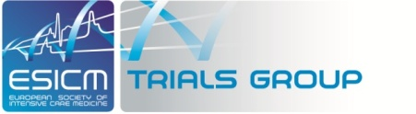

Application form – Call for proposal –Trials Group Award

Title

Design

Acronym
Name of the PI + contact details* (the project Principal Investigator (PI) must be an ESICM member and must be practicing in a European centre)
ESICM section or working group
Expected start date + duration
Rationale/Objectives
Project summary
Potential steering committee members

Accrual: target number of patients to be included

DSMB (yes or no)
Ethical issues (yes or no)
Insurance: mention if you will require an insurance (mandatory for interventional trial)
Specific budget (you can add an excel table)
Can you describe in a few lines in what terms the trial would be innovative and contribute to the knowledge and/or progress of intensive care medicine
Please provide the protocol (even in a final draft form) with this application form.
Make sure the protocol contains the inclusion and exclusion criteria, methodology, target population, primary and secondary outcomes, etc

Address this form and appendixes to your Chair of section (only one application per candidate overall).

The Chair of each section can send up to 3 selected protocols to Pr Dr Lui FORNI, Chair ESICM Research Committee and copy to reseach@esicm.org

